Digital approaches to Righas Velestinlis’ Charta, the 18th century cartographic monument of Greek cultural heritage

M. Pazarli, N. Ploutoglou, K. Papadopoulos¹, A. Tsorlini, E. Livieratos
Aristotle University of Thessaloniki, Thessaloniki, Greece
¹ University of Macedonia, Thessaloniki, Greece

Introduction

Righas Velestinlis (1757-1798) is a major personality of the Greek Risorgimento and a top representative of the Greek Enlightenment in the late 18th cent. His ideas, intellectual involvement and revolutionary activism played an important role in the struggle of Greeks for independence in early 19th cent. influencing also the neighbouring people in the Balkans. Among Righas works, writings and translations, his cartographic production even limited in number of maps, is of particular importance. Especially his masterpiece, the Charta, a 12-sheet 2 X 2 metres map, printed in Vienna (1796 – 1797) in 1220 copies, representing almost the whole of Southeast Europe (the Balkan peninsula), is now considered (and recently proclaimed officially) a monument of Greek national cultural heritage.
Celebrating the 250th anniversary of Righas birth in 2007, a research project on Charta is under development focused on two main topics:
a) the analysis of its geometric framing and content (the geographic window);
b) the documentation of its toponyms.
The starting idea behind the project is that both topics should be interrelated and interactive in terms of the possibilities available from modern digital information and communication technologies. This task was feasible because of the recent digitization of one of the few known existing original copies of Charta preserved in the Thessaloniki University Library (almost only 2% of the printed copies are survived).
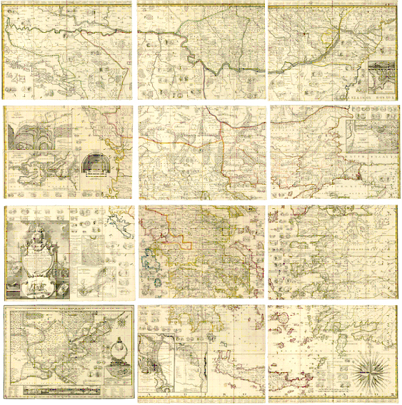
The 12-sheet Righas’ Charta (1796-97), Courtesy AUTh Library.

Charta’s geometric and thematic content

Despite its historical cartographic importance, Charta is known, among few experts, principally from a scholar or literary point of view, concerning mainly its history and its symbolic semantics. Analyses related to pure cartographic issues of this map, geometric (coordinates, projection etc.) and thematic (the non-geometric map content) and in its intrinsic properties (usually not apparent in a direct map-reading) are extremely limited almost missing in the cartographic literature.
In particular, Geometry (geometric content) refers to:
- Geo – Framing (window)
- Geo – Reference (coordinate parameterization)
- Scale variation
- Linear, angular and surface deformation
- Coastline featuring and relation (models)
- Affinity with other relevant maps
- Sheets assembling
- Corrections in 1:1 scanning / photo
- Projective properties and compatibility (origins)
while Thematics (thematic content) are related to:
- Mosaicing of themes (toponymy, texts, graphics, images, coins, symbols, names, mythology, archaeology)
- Thematic geo – reference (Charta vs actual coordinates)
- Combination of a theme by linking to other themes (multiplicity)
- Thematic Data Base development and management
- Access, communication (considering the general public, education, etc,)

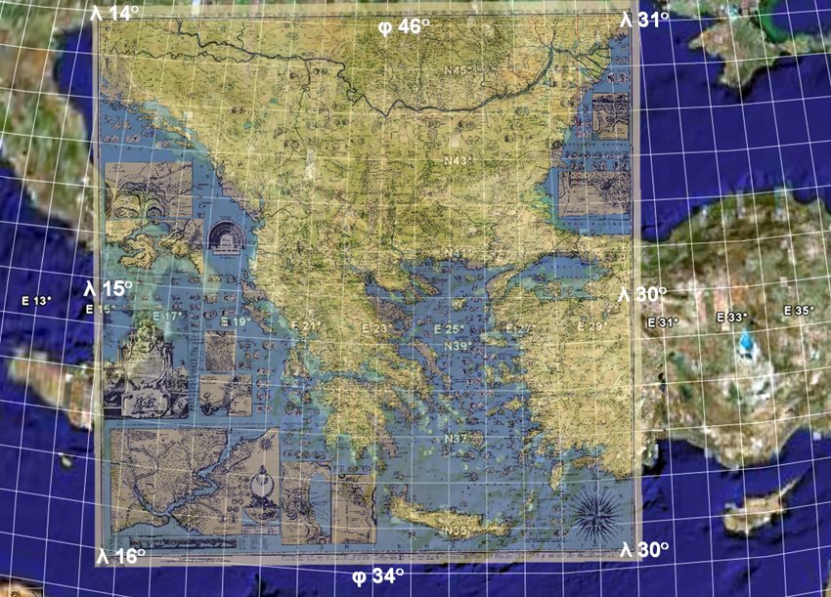
The Righas’ Charta best fitted on modern Google Earth representation

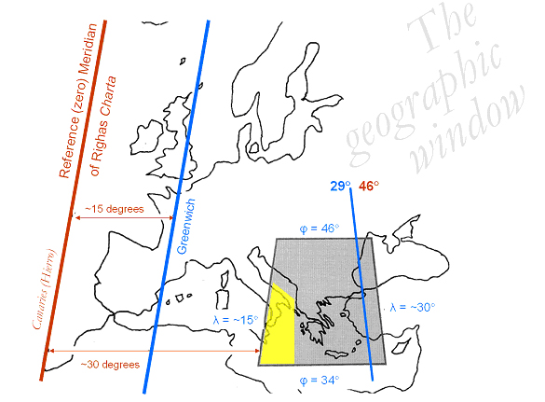
The geographic window of Righas’ Charta. In yellow the missing representation of SE Italy, replaced by the Cartouche and other thematic depictions.

Geometry is ‘polarizing’ the map surface via coordinates, while the thematic content is related to the geometric content via coordinates too. A useful procedure, with many possible implementations, is the Georeference of the thematic content that is relating the geometric content to the thematic information.
The methodology designed especially for this project is targeted in getting full profit of the digital transformation of the original map into a relevant actual map. Intrinsic and extrinsic georeference is implied on Righas map and coupled using a number of appropriate tests for the best fitting.

Charta’s Toponymic Digital Lexicon

An implementation of our research till now, on Charta’s thematic content, is a georeferenced digital dictionary, the Toponymic Digital Lexicon. The goals of our research, are, step by step the following: a. the thematic data entry and type, here the toponyms concerning the name, the lettering size, style, differentiation etc, b. the determination and documentation of toponyms positioning, using multiple positioning techniques as far as the mane placement is concerned c. the database development and d. the way we manage to have automatic access to the database information and to the map’s extract we are interested for educational, communication and other uses.
The development of the toponyms’ lexicon was accomplished with a database which consists of the following fields: a simplified writing of the toponym given in Charta, in order to make the search easier, the geographical identification, the Righas’ writing, the modern toponym, for these cases that the identification was possible, the number and the name of the relevant map sheet, the coordinates of the toponym (only of the first letter, concerning that is not always to the same relevant position with its symbol), the symbols coordinates (only when we have a point symbol).

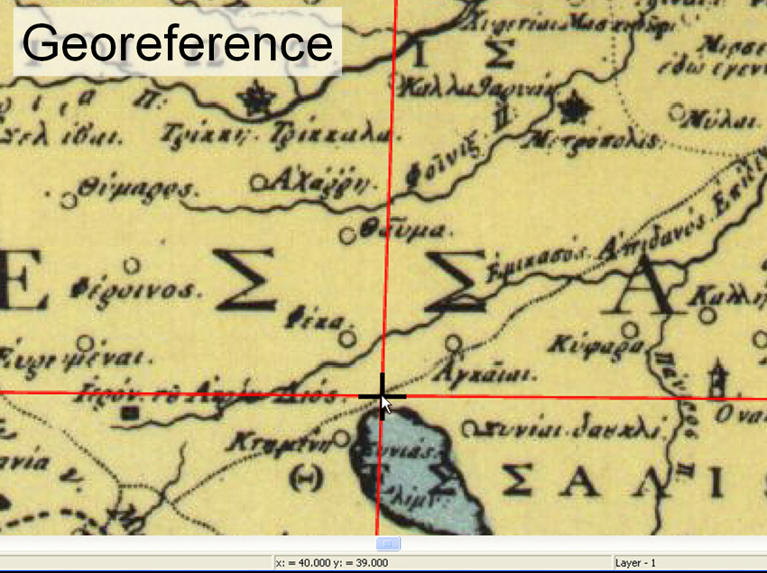
The georeferenced Charta in the coordinate system used by Righas

After the database is complete, we proceed to the development of the Search Engine. One of our intensions for toponyms’ Lexicon is to have a wide usage from the non-specialized public so we wanted a simple in structure and usage database. For the automatization access to the digital database we produce a search engine tool with visual basic. The user has easy access to search the database and spot the toponym, only by filling in the toponym as the “key word”. In particular, in the ‘Toponymic Digital Lexicon’ the user first has to fill in the geographical identification and then the toponym (combo boxes) or just the toponym.
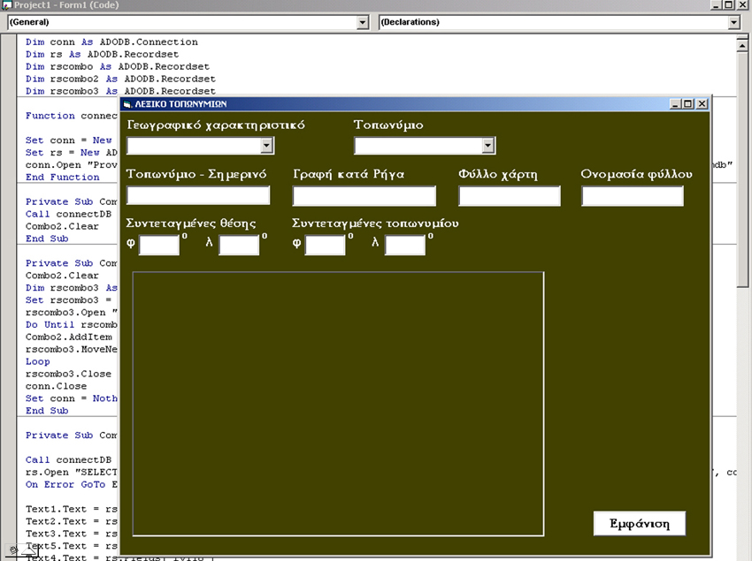
The interface of Toponyms Digital Lexicon

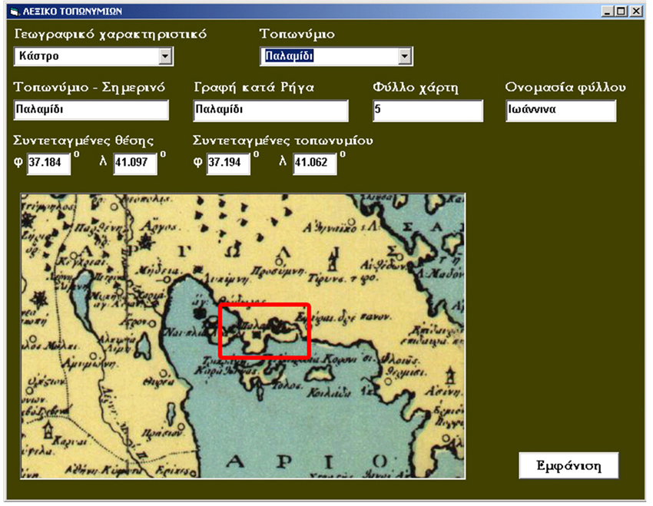
The search result of our query

Finally, we have as a result, all the available documentation: modern toponym, Righas’ writing, number of the map sheet etc. and of course the map extract, focused on our search.

Next step to our research is the combination with modern coordinates. In order to combine in a modern map the given Charta’s toponyms, by using modern digital tools, like for example the 2W software developed by the IUAV / CIRCE group in the frame of the cooperation with the Cartography Group at the Faculty of Surveying Engineering of the University of Thessaloniki, we can have today’s φ and λ (latitude and longitude), that is the modern coordinates: an impressive example with many implementations in research, education etc.
A study on the relevance of Righas Charta toponyms with the modern counterparts and the Ptolemaic toponymy tradition is also part of the research, as well as the relevance with toponymy given in other maps, seemed that served as references. An implementation setup on the possible uses of such Charta-related digital tools in education and history teaching and research, is also designed for generalization of the concept.

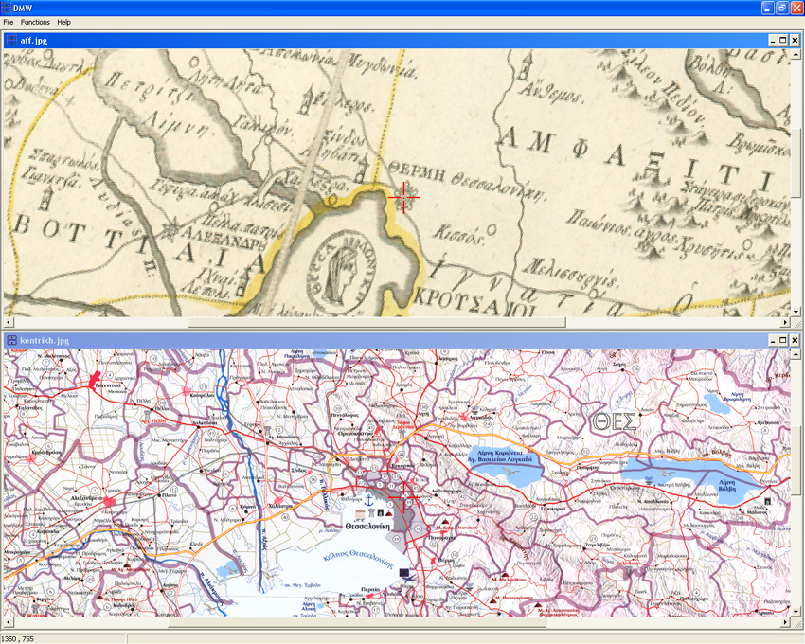
Righas’ Charta extract and the same area in a modern map in the program 2W.

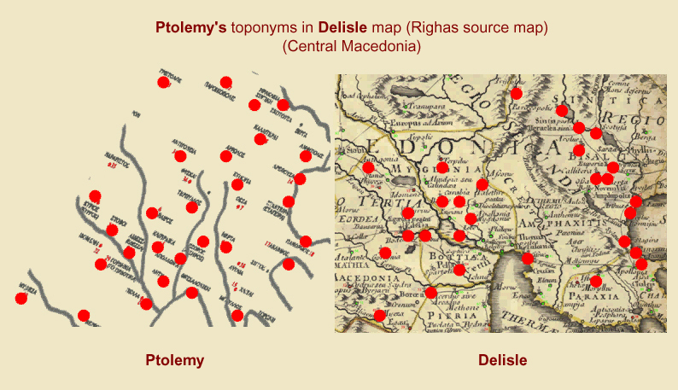
Ptolemaic toponyms in Delisle’s map which is one of the main Righas’ source maps.

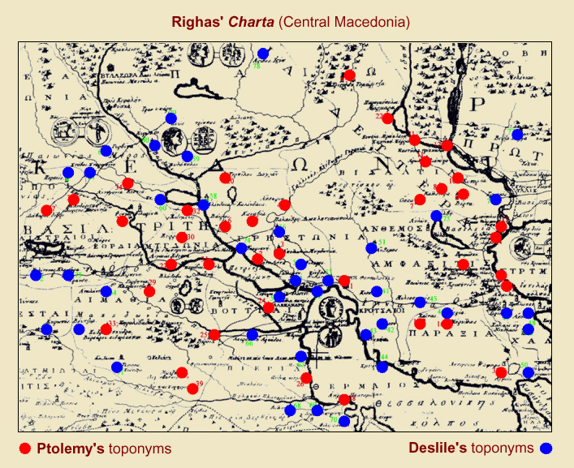
Righas Charta toponyms from Ptolemaic maps and from Delisle’s map.

References

Guiomar, J.-Y. et M.-T. Lorain (2006). La carte de Grèce de Rigas et le nom de la Grèce, Annales historiques de la Révolution française, Numéro 319, on line URL : http://ahrf.revues.org/document106.html

Hellenic Cartographic Society (1998). 200 years of Righas’ ‘Charta’, 1797-1997 [in Greek], E. Livieratos (Ed.), HCS - Paratiritis, Thessaloniki.

Livieratos, E. (1998), A tour into Cartography and maps: 25 centuries from the Ionians to Ptolemy and to Righas [in Greek]. National Centre for Maps and Cartographic Heritage, Thessaloniki.

Livieratos, E. (2007). On the cartography of Righas Charta, 2nd International Workshop on Digital Approaches to Cartographic Heritage: A digital look at Righas Charta, ICA Workshop, Athens 18-19 May.

Ploutoglou, N., A. Tsorlini, E. Livieratos, C. Boutoura (2007). On the digital analysis of Righas Charta map-geometry, 2nd International Workshop on Digital Approaches to Cartographic Heritage: A digital look at Righas Charta, ICA Workshop, Athens 18-19 May.

Ploutoglou, N., M. Pazarli, K. Papadopoulos (2007). On the digital implementation of Righas Charta thematic content, 2nd International Workshop on Digital Approaches to Cartographic Heritage: A digital look at Righas Charta, ICA Workshop, Athens 18-19 May.

Melas, Victor (1997). Righas’ ‘Charta’ [in Greek]. National Bank of Greece Cultural Foundation, Athens.

Tolias, G. (2007). The Righas Charta in the context of Greek Enlightenment, 2nd International Workshop on Digital Approaches to Cartographic Heritage: A digital look at Righas Charta, ICA Workshop, Athens 18-19 May.

Prof. F. Guerra group, guerra2@iuav.it

